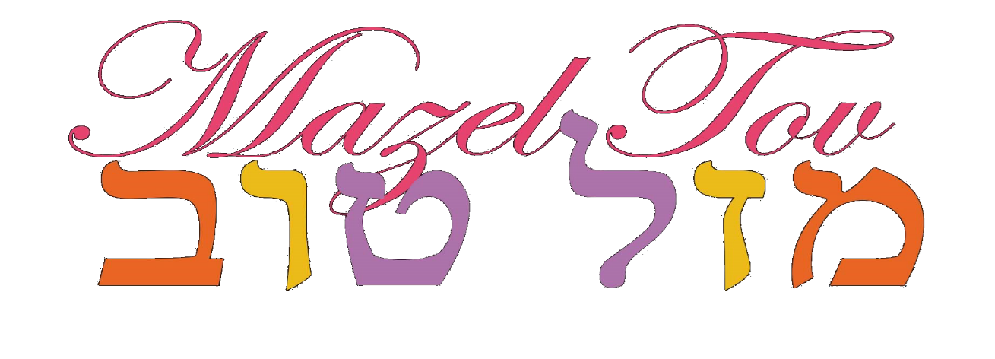

We are delighted that you will be celebrating your daughter’s Bat Mitzvah with us at HGSS.

The journey to your Bat Mitzvah at HGSS includes the following steps:

In Year 6 mothers and daughters participate in the Mother and Daughter Bat Mitzvah programme, led by the female members of our Rabbinic Team. It’s a year-long programme that studies women throughout the ages, and the girls begin their journey of understanding what it means to become Bat Mitzvah. The programme includes some text study, discussion and lots of experiential activities that involve all the girls and their mothers.

The following page shows a range of options for the way that your daughter and her family and friends can celebrate and mark her Bat Mitzvah at HGSS. A member of our Rabbinic Team will be delighted to meet with each family and discuss what kind of celebration you would like, and how to make it truly special and memorable.

Approximately 6-9 months before the date of your Bat Mitzvah we are happy to help you find a teacher to help your daughter prepare for her Bat Mitzvah. The tutor will be selected as a best match, taking into account your daughter’s interests, background and needs.

A few months before the big day you will meet with the Wardens to put the finishing touches to the day itself!

We are thrilled to accompany you on this journey and to celebrate this rite of passage with you and your family. Thank you for letting us be a part of your simcha.

Please contact Abi at abi@hgss.org.uk to book your Bat Mitzvah into the shul calendar or to arrange an appointment with Rochelle Freilich to discuss any of these options further.

If you would like to discuss hall bookings, please contact Sharon at Sharon@hgss.org.uk
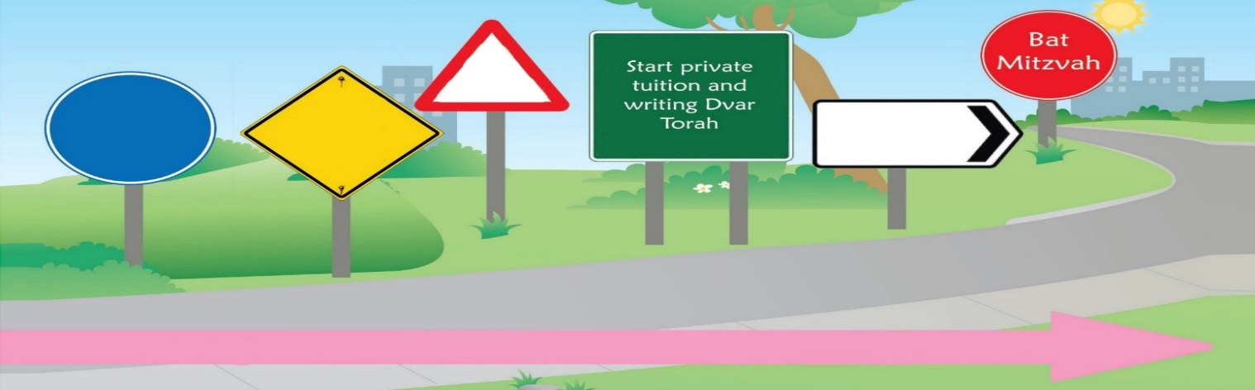

Meet
with Rebbetzen
Meet the Wardens
Fix
date
with Abi
Mother and Daughter Programme
HGSS Bat Mitzvah Celebrations

Girls celebrate their Bat Mitzvah once they have turned 12 years of age in the Jewish calendar, using one of the following options BUT NOT LIMITED TO THESE OPTIONS

FRIDAY NIGHT CANDLE LIGHTING: Before Shabbat comes in, your daughter has the opportunity to participate in a beautiful candle lighting ceremony and can deliver her Dvar Torah to her family and friends. During the ceremony the Bat Mitzvah Prayer and parents’ traditional blessings will be recited, and your daughter will be addressed by a member of our Rabbinic Team and be presented with a certificate, chumash & siddur. Since the candle lighting needs to be completely finished before Shabbat comes in, this option is most practical during the summer months.

FRIDAY NIGHT KABBALAT SHABBAT SERVICE: Your family and friends can be invited to participate in a mini Kabbalat Shabbat service in the main shul led by Chazan Avromi. Your daughter can deliver her Dvar Torah to all her guests. During the ceremony, the Bat Mitzvah Prayer and parents’ traditional blessings will be recited. Your daughter will be addressed by a member of our Rabbinic Team and be presented with a certificate, chumash & siddur. This option is most practical during the winter months.

SHABBAT MORNING SERVICES: During the Shabbat morning service in the main shul prior to Adon Alom, your daughter can deliver her Dvar Torah to the entire community, and will then be addressed by a member of our Rabbinic Team. She will also be presented with a certificate, chumash & siddur along with the traditional words of blessings. This option is available all year round.
SHABBAT PRESENTATION: During the Shabbat morning service in the main shul, your daughter will be addressed in front of the whole community by a member of our Rabbinic Team just before Adon Olam. In addition, she will be presented with a certificate, chumash & siddur along with the traditional words of blessings. This option is available all year round.

PRIVATE BAT MITZVAH CEREMONY AFTER KIDDUSH: Your family and friends will be invited to participate in a private ceremony in the main shul (at approximately 12.30pm) led by Chazan Avromi with Shabbat singing. Your daughter will deliver her Dvar Torah to her guests, and the Bat Mitzvah Prayer and parents’ traditional blessings will be recited. Your daughter will be addressed by a member of our Rabbinic Team and presented with a certificate, chumash & siddur. This option is available all year round.

HAVDALLAH SERVICE: Your guests are invited to participate in a private Havdallah ceremony, led by Chazon Avromi. Your daughter will deliver her Dvar Torah to your friends and family, followed by the Bat Mitzvah Prayer and parents’ traditional blessings. Your daughter will be addressed by member of our Rabbinic Team and be presented with a certificate, chumash & siddur. This service usually starts an hour after Shabbat ends, and consequently most practical in the winter months.

SUNDAY CEREMONY: This is a private service in the main shul where your daughter is able to deliver her Dvar Torah to her family and friends. Various songs may be included, alongside the Bat Mitzvah Prayer and parents’ traditional blessings. Your daughter will be addressed by a member of our Rabbinic Team and be presented with a certificate, chumash & siddur. There is also the option of starting the ceremony with a Havdallah ceremony. This option is available all year round.

WOMEN’S ONLY SERVICE: We can tailor many of our services such as Kabbalat Shabbat, Shabbat/weekday mincha, Rosh Chodesh, or Purim/Shavuot Megillah where your daughter can lead part of the service and deliver her Dvar Torah. The Bat Mitzvah Prayer and parents’ traditional blessings will be recited, as well as your daughter being addressed by a member of our Rabbinic Team and presented with a certificate, chumash & siddur. This option is available all year round, including some of the chagim.

PRIVATE FUNCTION: The Bat Mitzvah girl has the option of delivering her Dvar Torah during her function with all her family and friends. The Bat Mitzvah Prayer and parents’ traditional blessings will be recited, and your daughter will be addressed by a member of our Rabbinic Team and presented with a certificate, chumash & siddur. This option is available all year round but only possible if your function is kosher certified.

